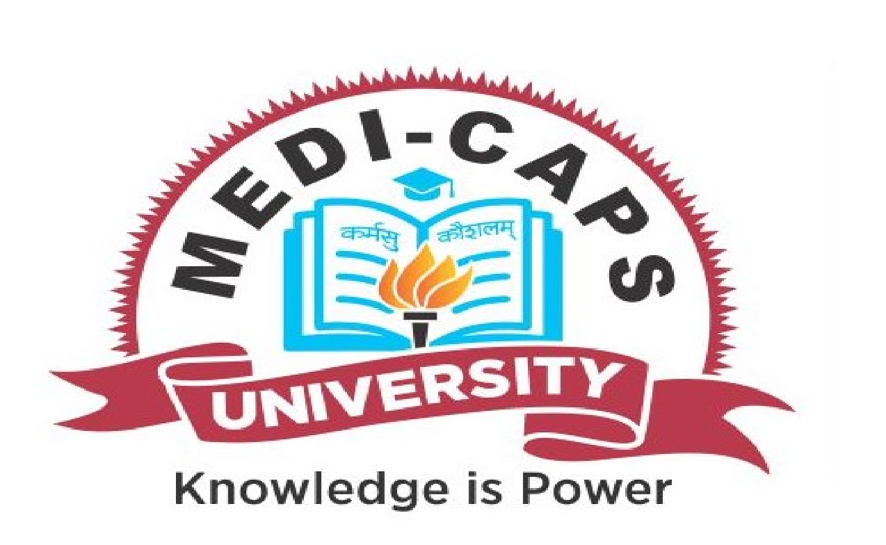

**Medi-Caps University, Indore**

**Report of Expert Lecture/Workshop/Symposium/Conference/Industry Visit/Meeting**

**Name of Expert Lecture/Workshop/Symposium/Conference/Industry Visit/Meeting:**

Demystifying Data Science

**Schedule (Date(s) and Time):** 12 June 2021 and 11:00 am

**Venue:** Zoom

**Duration:** 11:00 am to 1:00 pm

**Organizing Faculty/ Convener (s):** Dr. Dheeraj Rane

**Organizing Department:** MUACM

**Faculty Coordinators:**  Dr. Dheeraj Rane

**Total Number of Participants:** 175

**Expert(s) Profile: Dr. Neha Sharma** was the speaker for the event. She is the Senior Member of IEEE and the brain behind conceptualizing the **International Conference of Data Management, Analytics and Innovation** (ICDMAI), which has become a landmark conference in the field of data science.

**Objectives:**

1. Introduction of Data Science
2. Importance of Data Science

**About the Expert Lecture/Workshop/Symposium/Conference/Industry Visit/Meeting:**

**(summary of the event in 200 words)**

Presenters/Coordinators: Dr. Neha Sharma/ Riya Ahuja

The event focused on the introduction to the domain of data science and the need of data science. Participants were really thrilled to know how one can become a successful data scientist. The event was very successful in making us realize how we produce a lot of data on a day-to-day basis, and how we can use that data for the betterment of our lives.

We also learnt how data science plays an essential role in tracking and slowing down the impact of coronavirus. The audience was really interactive and many doubts & questions regarding data science were answered. To sum up, the session was really informative. The knowledge of the speaker and the eagerness to learn within the participants combined really well to create a healthy learning community.

**Conclusion & Remarks:**  The event created a lot of buzz among the students. We got over 200 registrations, from which around 150 attended the event. The event started at 11:30 AM and ended with an interactive discussion on data science at 1:00 PM.

**Any other (**as per requirements**):**

**Photographs:**

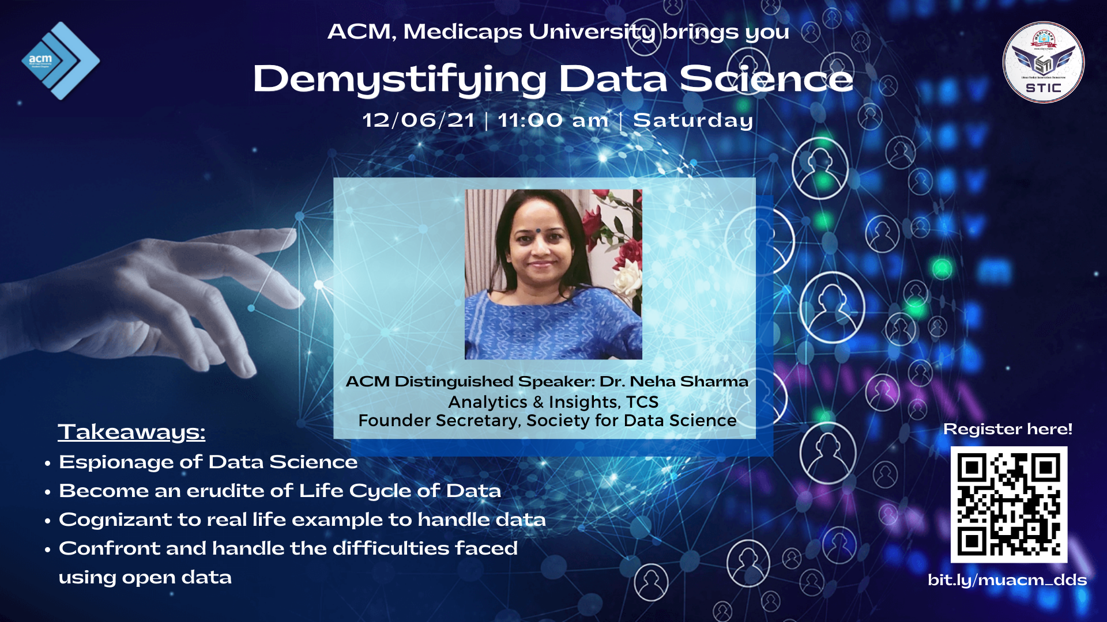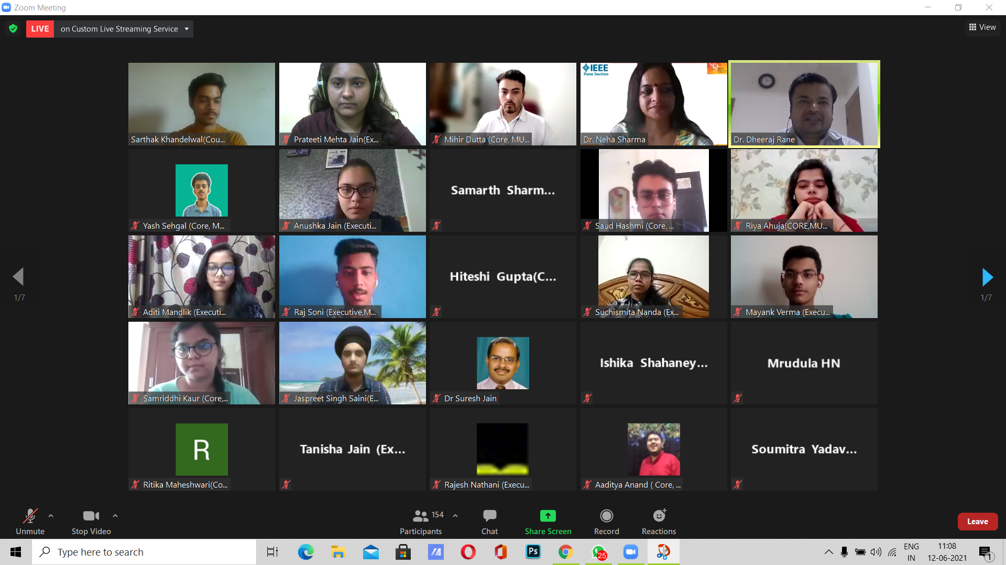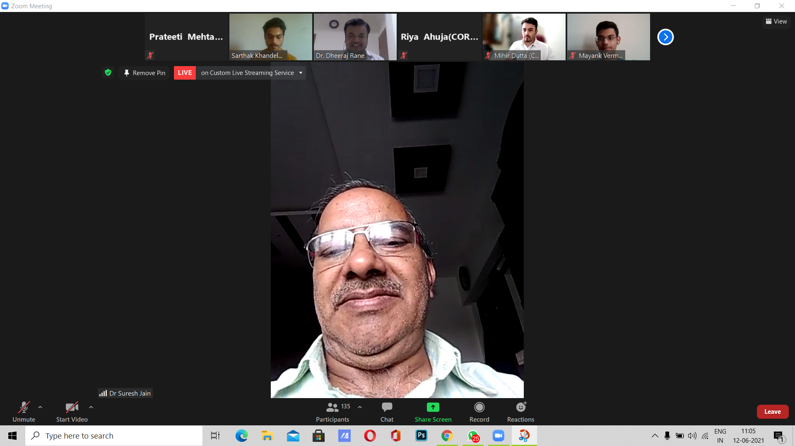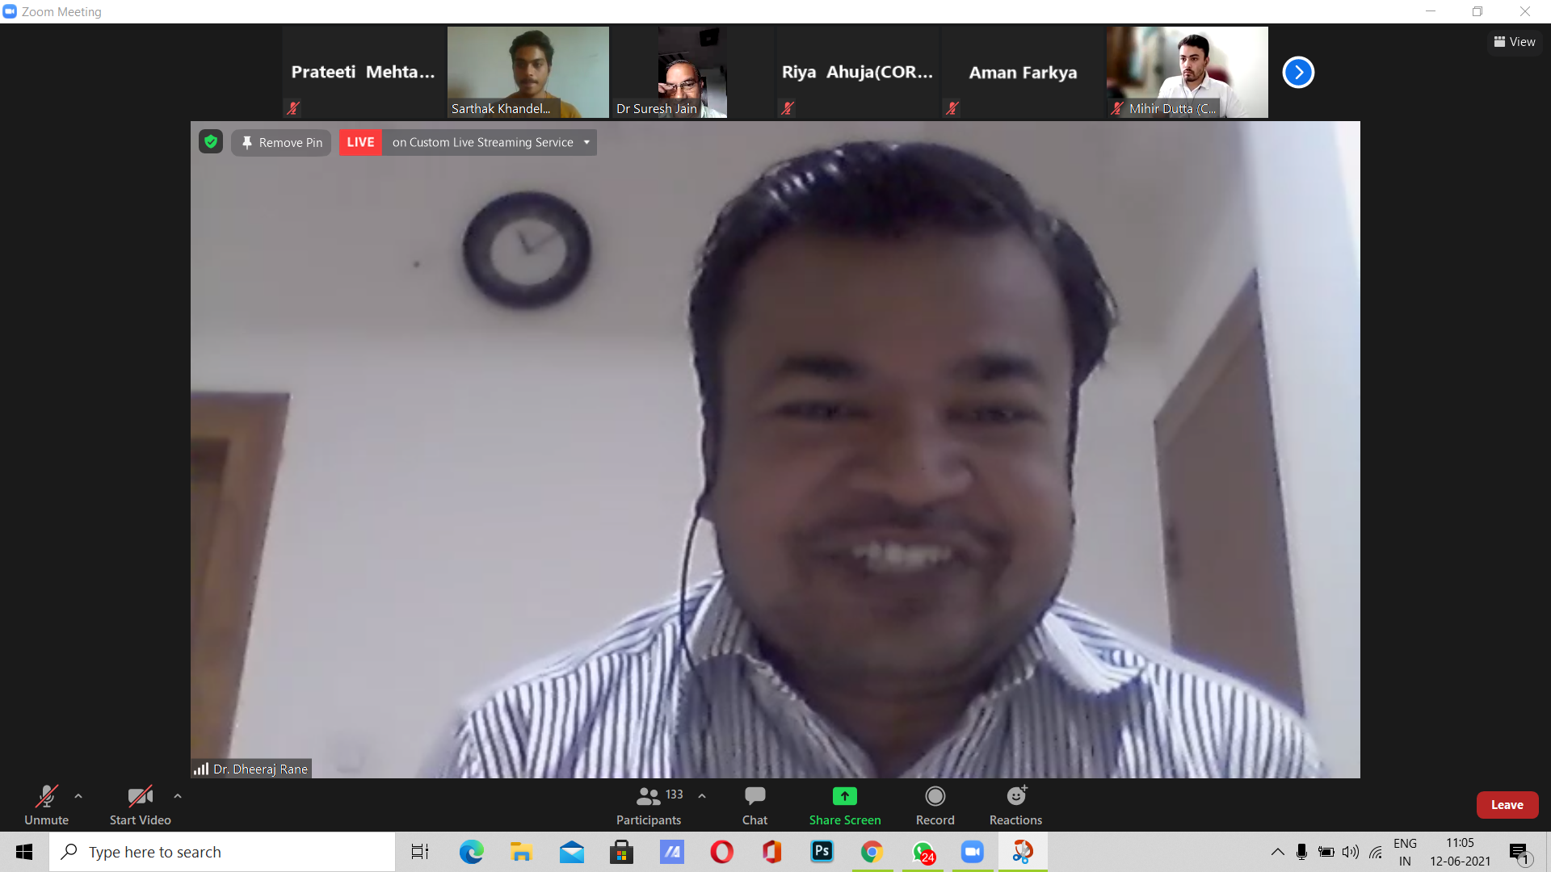

**List of Participants:**

**Signature of Convener / Organizing Faculty member.**

**Note:** Soft copy of this report with all attachments/ photographs/ annexures/ links to be submitted to itmc[**@medicaps.ac.in**](mailto:sarita.kansal@medicaps.ac.in)and [**iqac_mu@medicaps.ac.in**](mailto:iqac_mu@medicaps.ac.in)**.**